PETE 219: Data Analytics Group Project
Instructors: Thomas Seers & Ahmed El-Agnaf
thomas.seers@qatar.tamu.edu

Introduction
In groups of four, you will utilize the concepts and methods that you have acquired during PETE 219 to undertake a data analytics project using key subsurface datasets:
- Well logs.
- Poro-perm / facies description datasets.
- Pore-scale images of reservoir facies.
This project will contribute 15% towards your total mark for PETE 219. Specifically, you will utilize these datasets to assess reservoir quality / reservoir potential for a single well, conduct supervised / unsupervised ML on RCAL data and visualize (and potentially analyze) production data. Though rewarded, technical insights from the subsurface perspective are less critical in this assessment than the technical ability in data analytics demonstrated in your Python project’s workflow. Another key thing to consider is that any attempt to move beyond the tools and concepts presented within PETE 219 will be greatly rewarded: you cannot learn to code without exploring Python’s vast functionality yourselves!

Tasks
Project Management
You are required to manage your project using GitHub. You will need to select one group member as the project owner, with the other group members acting as collaborators. You GitHub project should contain your data, code and ancillary items (README.md, report, presentation: see previous lab). We will actively look for evidence of collaboration on your GitHub project (edits / commits).
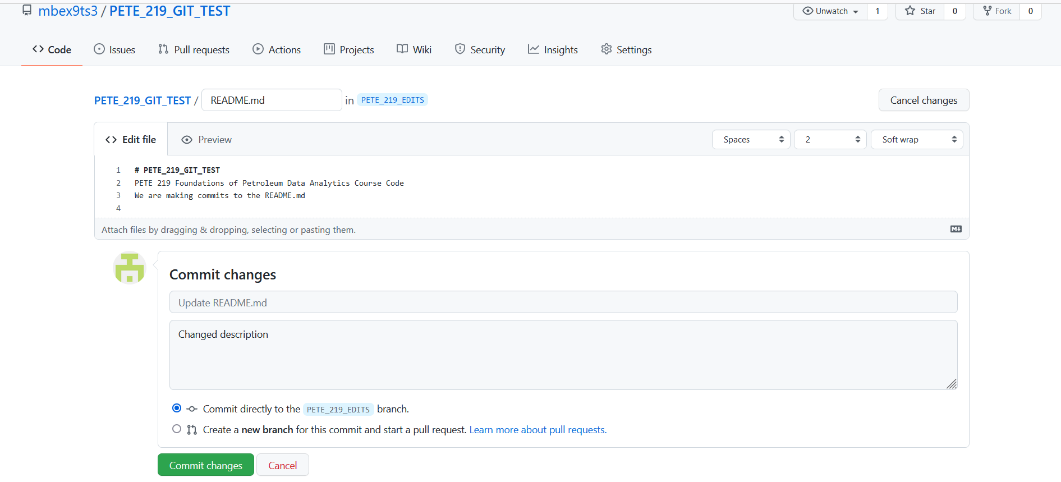
Well Log Analysis
For your wireline log data, you need to approach the analysis in a stepwise fashion:
- Data import and cleaning: what libraries did you use to parse your data (nb: pip install lasio)? What exploratory data analysis did you perform to identify anomalies/outliers? What artifacts did you encounter in your raw dataset and what was your strategy for cleaning these anomalous elements (replacement with null values / nan, interpolating between nearest neighbors, flipping sign etc.)?

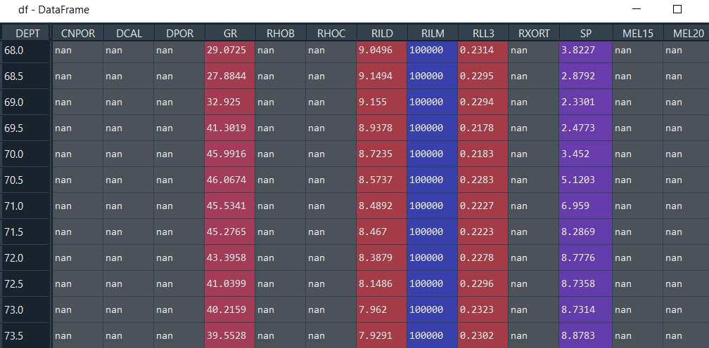

- Data visualization. you should aim to display your log data in multiple ways: e.g. classic log profiles, histograms of log properties, cross-plots of potentially correlated properties etc. Credit will be given for going beyond the lab examples provided within PETE 219 (for example can you plot the neutron-density plot with infill / put your logs on a single plot? See below and https://towardsdatascience.com/enhancing-visualization-of-well-logs-with-plot-fills-72d9dcd10c1b)
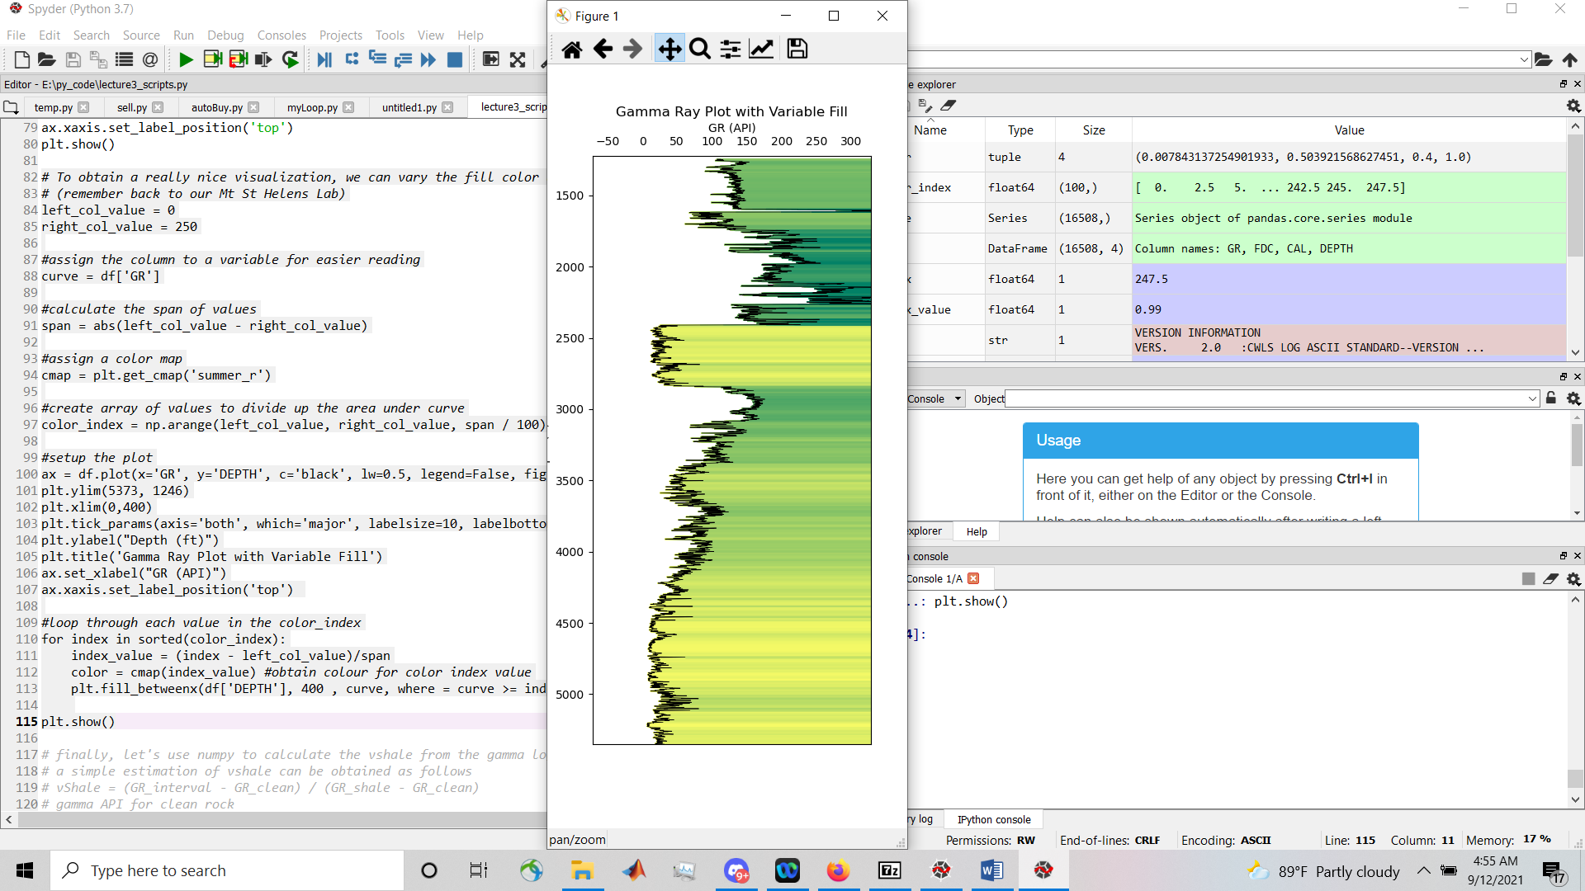
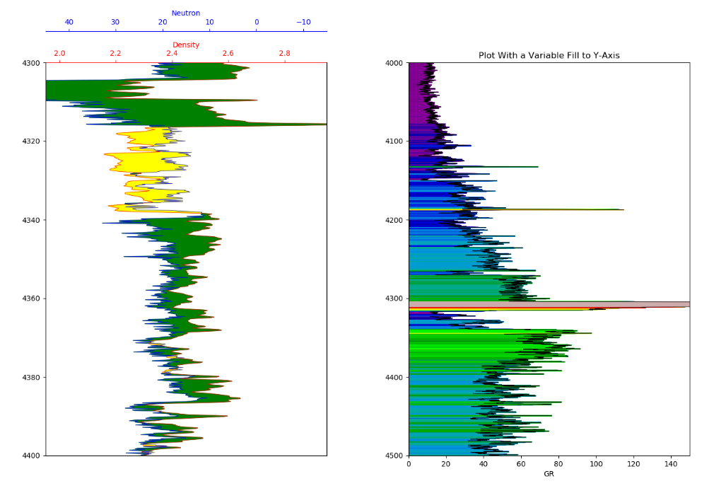

- Data analysis: consider which logging suites are most valuable for assessing reservoir quality and potential and focus on these: GR, RILD-RIL3, CNPOR-RHOB). The basic target of your analysis should be the following: v-shale cutoff and net-to-gross; locating high quality reservoir facies (GR) and correlating these with potential oil/gas shows (estimating total reservoir thickness / hydrocarbon column height, differentiating oil vs. gas reservoir etc.; assessing the distributional form of various log properties (negative vs. positive skew etc.); locating correlateable properties (linear regression). Credit will be given for the development of bespoke functions applied to your data frame (e.g., calculating effective stress from RHOB and DEPTH).
Poro-perm Data Analysis
- Data import and cleaning: Again, data cleaning should be an important consideration. Be aware that I will be doctoring values in your input dataset.

- Data visualization: there are multiple opportunities to visualize your dataset: cross plots with different markers for facies, histograms and P-P plots to evaluate distributional form etc.

- Data analysis: In similitude, you can use linear regression to quantify correlations (supervised ML), utilize K-means clustering to determine clusters (unsupervised ML) and ANNs to classify by facies (supervised ML). You can also deploy AD tests to evaluate normality in both datasets.

Image Analysis
- Data import and cleaning: No anomalous values here. However, this dataset would benefit from denoising (see median or non-local means filter (https://scikit-image.org/docs/stable/auto_examples/filters/plot_nonlocal_means.html)

- Data visualization: basic visualization of grayscale and binary images. Advanced visualization of separated pores. Heat maps of pore size.

- Data analysis: Simple porosity estimates. Kozeny-Carman estimates of permeability. Blob analysis of pore size etc.

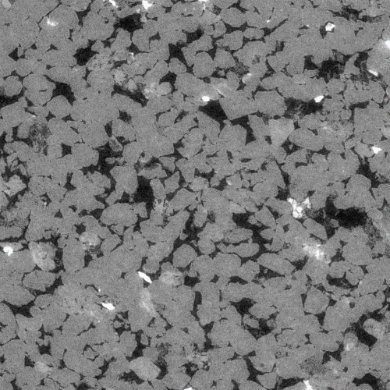

Deliverables
- A GitHub project containing all code, data and ancillary materials associated with the group project (readme.mp, report,
- Group report: maximum 3500-word group report detailing your analysis workflow. Appendices should be provided containing your code scripts and referenced within the text.

Mark (%) | 60-69 | 70-79 | 80-89 | > 90
Written content  (10%) | Very poor use of English with numerous spelling and grammatical errors. Sentences often illegible. Report lacks logical structure. | English is over simplistic but generally competent. Some spelling or grammar errors. Report is poorly structured | Good use of English in terms of structure and vocabulary. Few spelling mistakes or grammatical errors. Report is clearly organized. | Written English is of an excellent standard: stylistically attractive and ostensibly free of grammatical errors. Report is logically structured.
Analysis  (40%) | Very poor: inappropriate / naive use of the base functionality. Does not meet the level of the class examples for each given dataset. | Fair: is a reasonable replication of the basic analysis of each dataset conducted in class. | Good: analysis is appropriate and justified. Represents a highly competent reproduction of the class examples. Code projects runs without errors. | Exceptional: innovative and justified. Goes well beyond the class examples.
Literature and referencing  (10%) | Little evidence of robust literature (textbook or journals). Information is mostly derived from websites. No in text citations / many missing references or uncited literature / inconsistent formatting. | Some use of robust literature, though this is limited to introductory textbooks. Reference list and in text citations present but with some omissions and inconsistencies. | Good effort to engage with the topic’s associated literature. Some usage of primary source literature. The work is well referenced using consistent formatting, albeit with a few errors. | Shows ample evidence of engagement with a wide range of challenging literature, especially primary sources (research papers). Referencing and in-text citations are comprehensive, consistent and practically free of errors.
Visualization  (40%) | Minimal and inappropriate visualizations. Many formatting errors. | Basic reproduction of class examples with some formatting errors. | Comprehensive reproduction of class examples / formatting is comprehensive. | Extensive and novel use of visualizations which go beyond the examples undertaken in class. Formatting is comprehensive

